# Snowflake Introduction

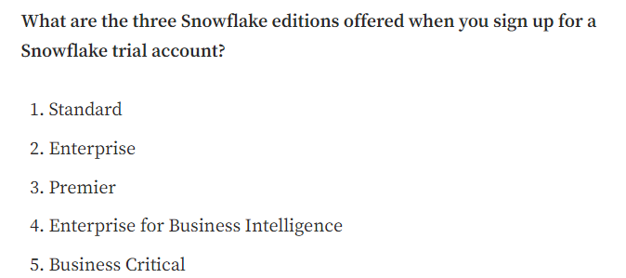

Solution: 1, 2, 5.

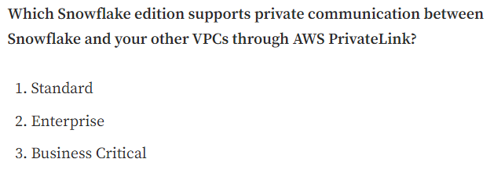

Solution: 3.

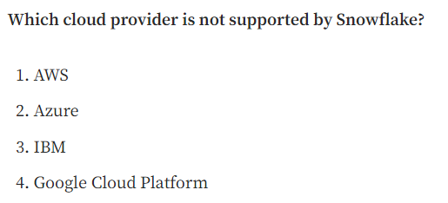

Solution: 3

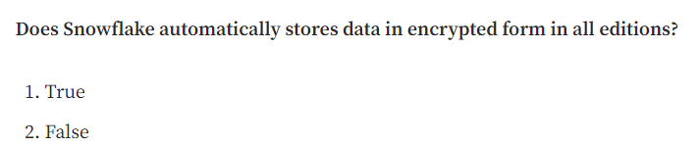

Solution: 1. Snowflake encrypts all customer data by default at no additional cost.

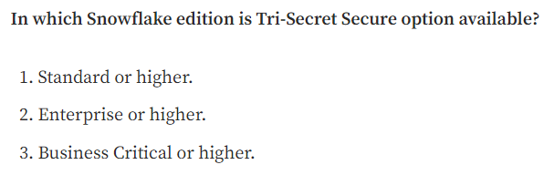

Solution: 3. The minimum edition to have Tri-Secret is the Business Critical one.

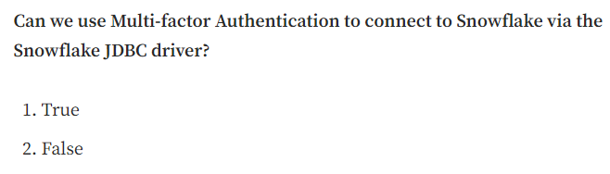

Solution: 1.

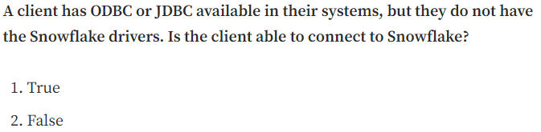

Solution: 2. You will need the Snowflake ODBC or JDBC driver to connect to Snowflake; just having JDBC and ODBC will not solve the problem. You can download it through the UI Interface.

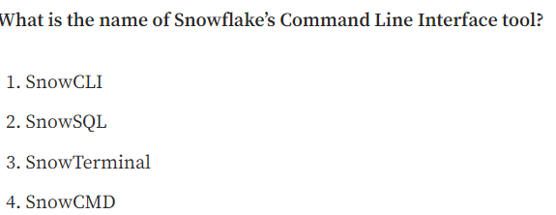

Solution: 2

# Snowflake Architecture

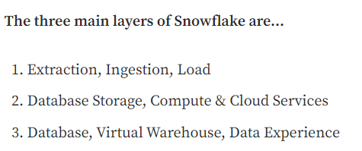

Solution: 2.

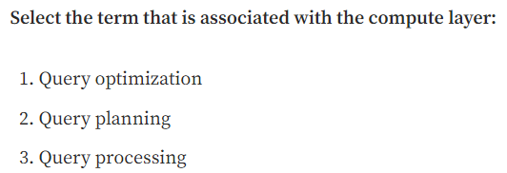

Solution: 3. You can find the name of the layers in different ways, like Query Processing for the Compute Layer.

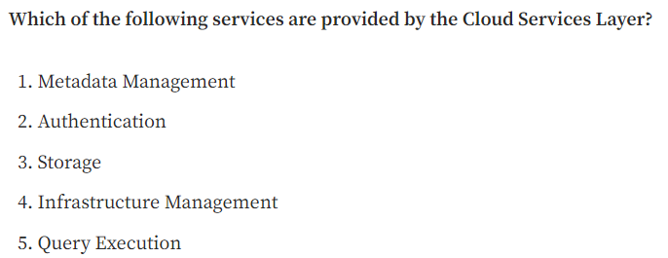

Solution: 1, 2, 4.

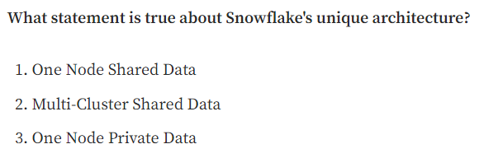

Solution: 2.

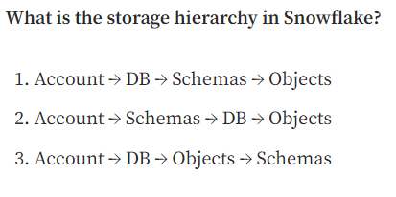

Solution: 1.

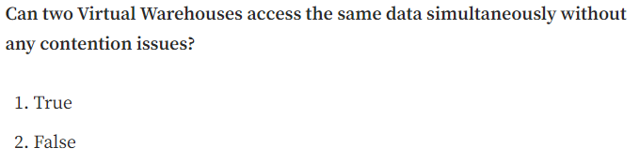

Solution: 1. We haven't seen this topic in-depth, but this is the main reason for the "Shared Data" concept. All the data is in the same place, and the Virtual Warehouse has access.

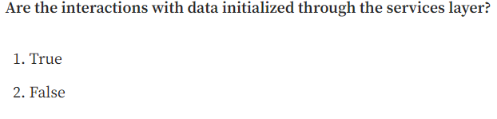

Solution: 1. Cloud services tie together all of the different components of Snowflake to process user requests, from login to query dispatch.

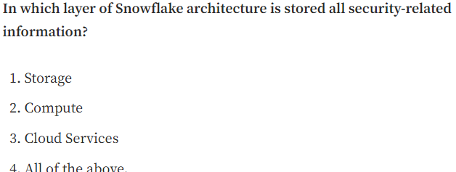

Solution: 3.

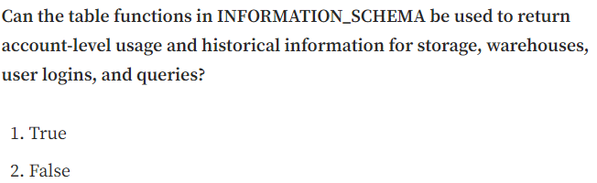

Solution: 1.

# Third Chapter: Snowflake Pricing

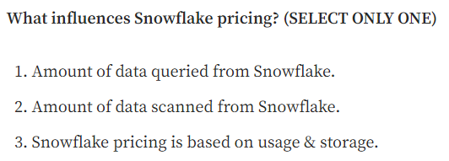

Solution: 3.

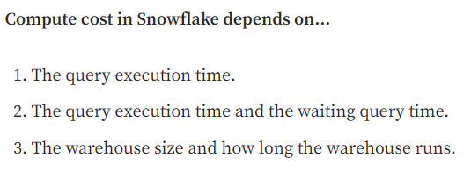

Solution: 3. The cost does not depend on how many queries you run in the warehouse. It depends on which warehouse size and how long the warehouse runs.

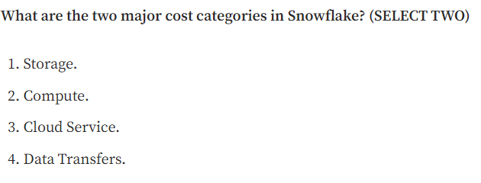

Solution: 1, 2. These are the main costs in Snowflake, and it’s always a good idea to build solutions trying to reduce these costs, like using caches, as we will see in the next chapters.

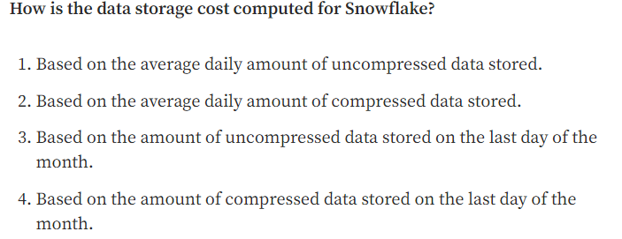

Solution: 2.

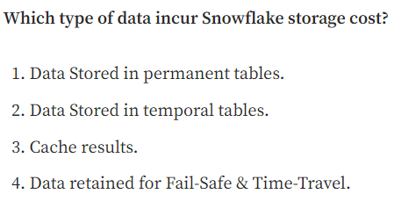

Solution: 1, 2, 4. It also includes data stored in Snowflake locations (i.e., user and table stages or internal named stages).

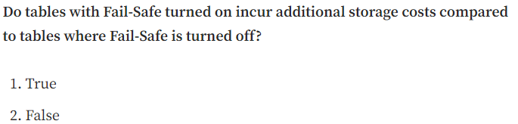

Solution: 1.

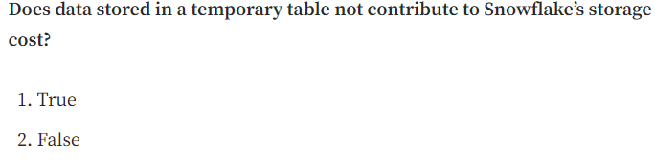

Solution: 2.

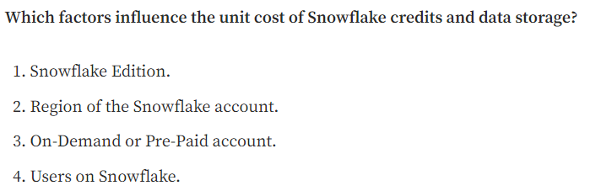

Solution: 1, 2, 3.

# Fourth Chapter: Micro-partitions

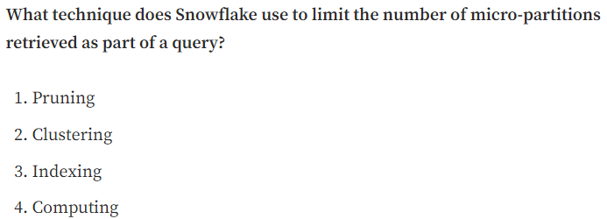

Solution: 1.

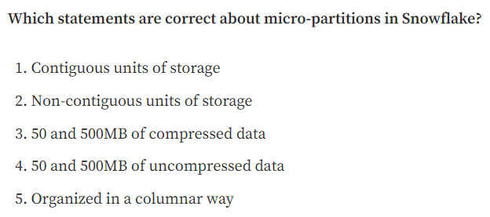

Solution: 1, 4, 5. This definition is a must, and we need to know it perfectly “All data in Snowflake tables are automatically divided into micro-partitions, which are contiguous units of storage between 50 and 500MB of uncompressed data, organized in a columnar way”.

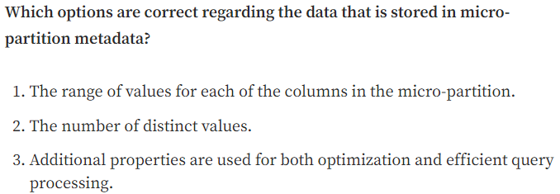

Solution: 1, 2, 3. All of them are true.

# Fifth Chapter: Clustering

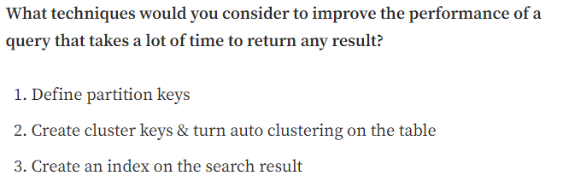

Solution: 2.

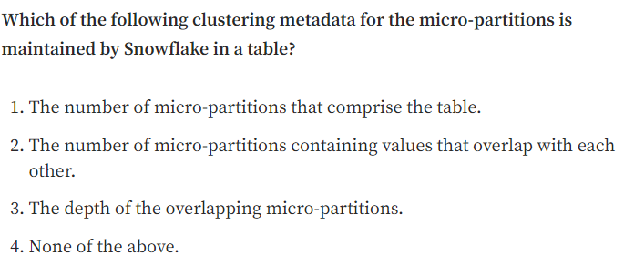

Solution: 1, 2, 3.

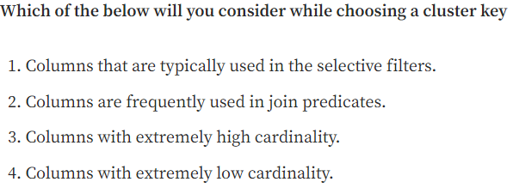

Solution: 1, 2. A column with very low cardinality (e.g., a column indicating only whether a person is male or female) might yield minimal pruning. At the other extreme, a column with very high cardinality (e.g., a column containing UUID or nanosecond timestamp values) is also typically not a good candidate to use directly as a clustering key.

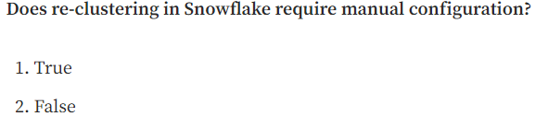

Solution: 2.

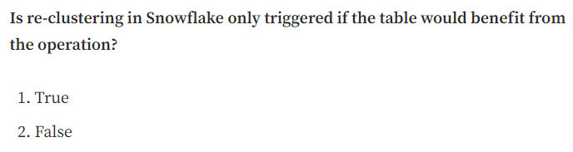

Solution: 1.

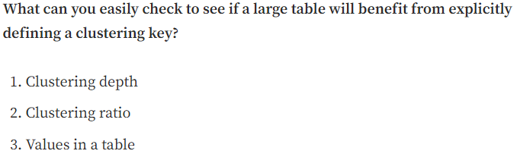

Solution: 1.

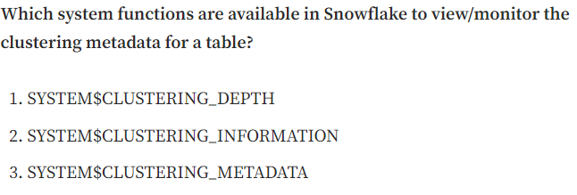

Solution: 1, 2.

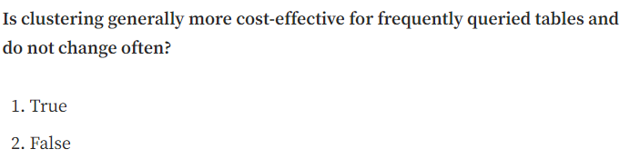

Solution: 1. The more frequently a table changes, the more expensive it will be to keep it clustered.

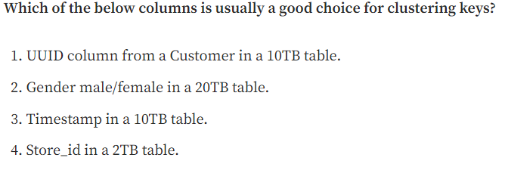

Solution: 4. It cannot have extremely high and low cardinality. UUID and timestamp have extremely high cardinality, as there will be a lot of customers/timestamps. Gender low cardinality. Store_id looks like the most convenient option.

# Sixth Chapter: Tables & Views

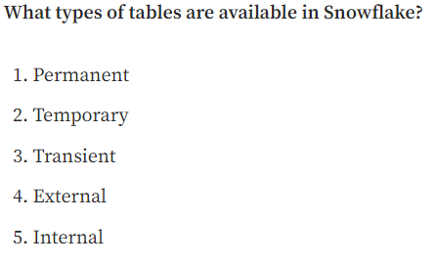

Solution: 1, 2, 3, 4

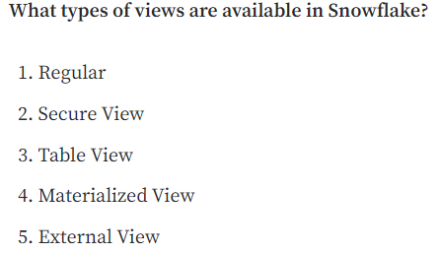

Solution: 1, 2, 4

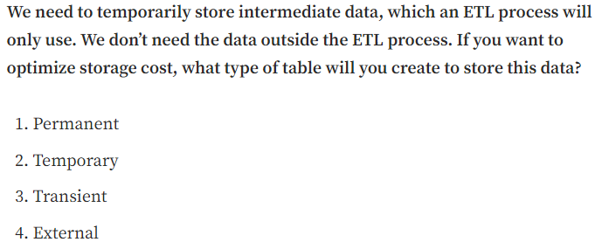

Solution: 2.

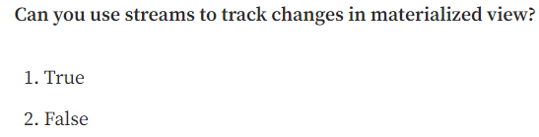

Solution: 2. This is a limitation of materialized views.

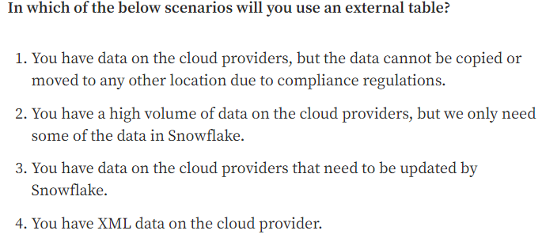

Solution: 1, 2. The third answer is incorrect, as external tables can only read data. They also don’t support XML.

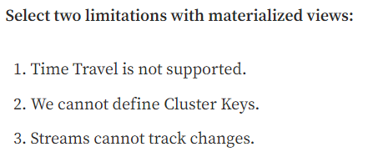

Solution: 1, 3

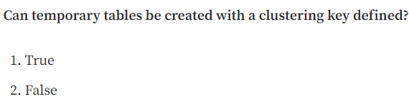

Solution: 1

# Seventh Chapter: Stages & Storage Integration

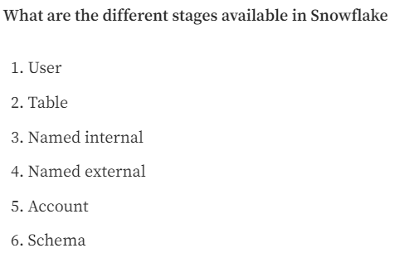

Solution: 1, 2, 3, 4

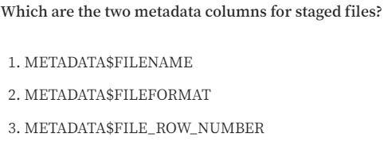

Solution: 1, 3

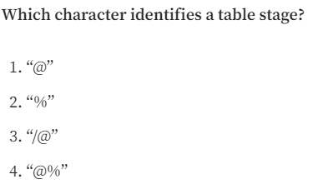

Solution: 4

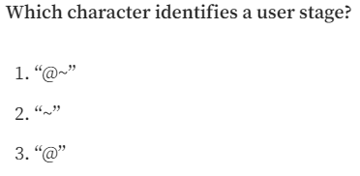

Solution: 1

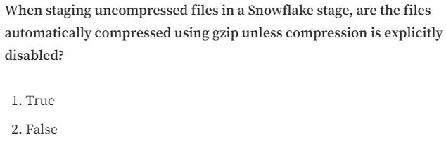

Solution: 1.

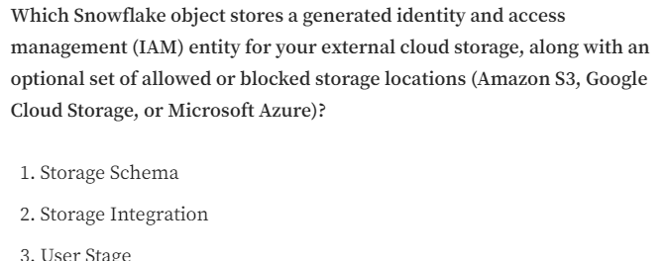

Solution: 2

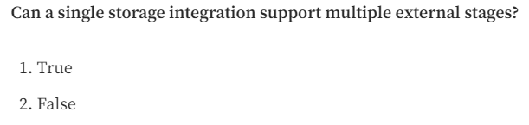

Solution: 1

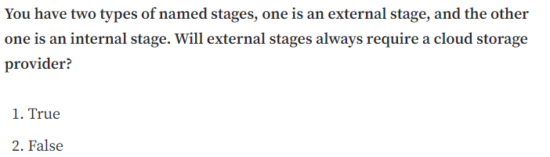

Solution: 1

# Eighth Chapter: Data Loading

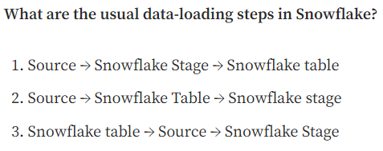

Solution: 1

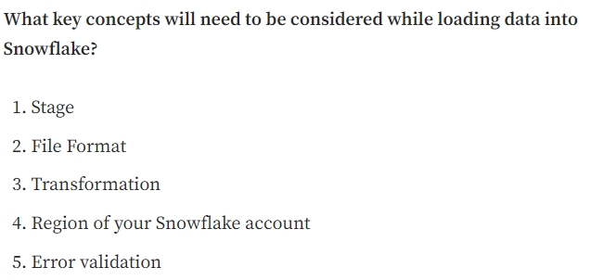

Solution: 1, 2, 3, 5.

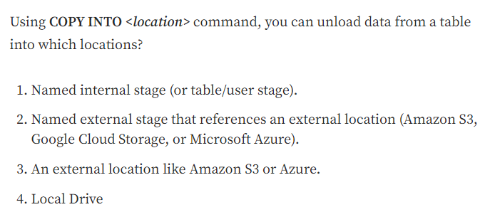

Solution: 1, 2, 3. Once the data is in the internal stage, you can download them into your local drive using the GET command. You can also unload data into an external location.

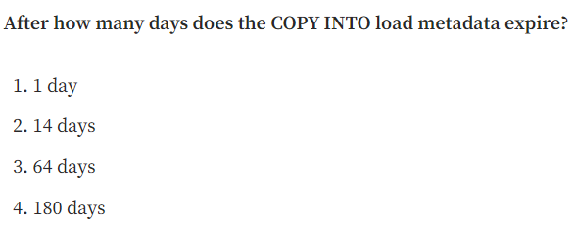

Solution: 3

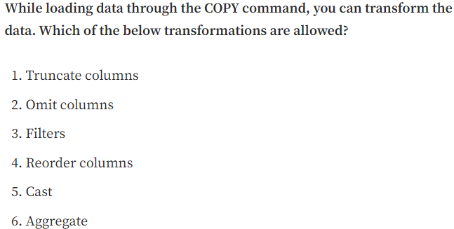

Solution: 1, 2, 4, 5

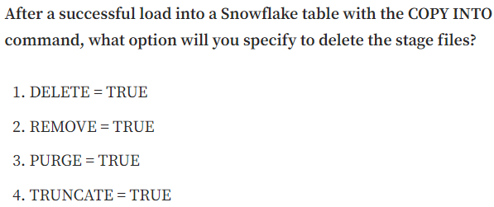

Solution: 3.

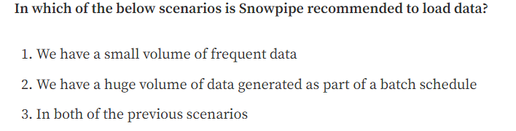

Solution: 1

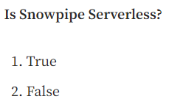

Solution: 1

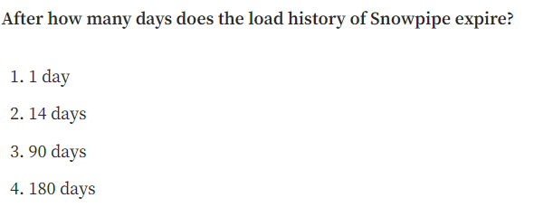

Solution: 2. The load history is stored in the metadata of the pipe for 14 days. Must be requested from Snowflake via a REST endpoint, SQL table function, or ACCOUNT_USAGE view.

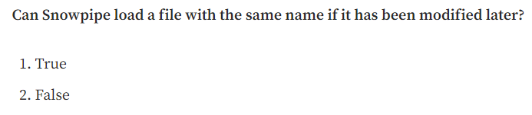

Solution: 2. This is because of the Snowpipe metadata. Changing the name doesn’t modify this metadata, so it won’t be copied.

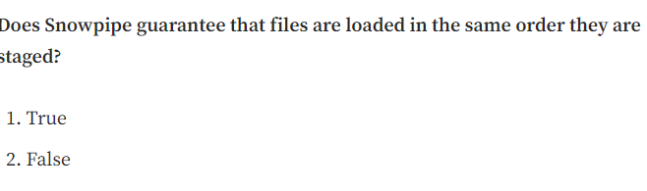

Solution: 2. It usually processes the oldest files first, but there is no guarantee.

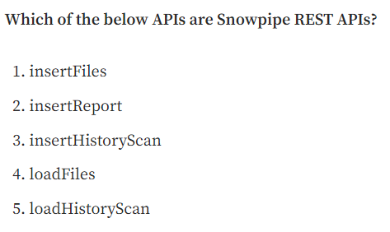

Solution: 1, 2, 5

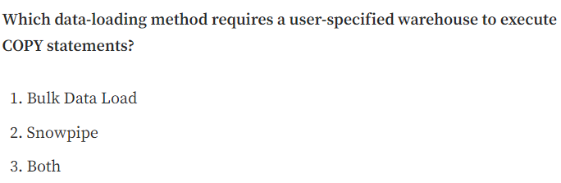

Solution: 1

# Ninth Chapter: PUT and GET commands

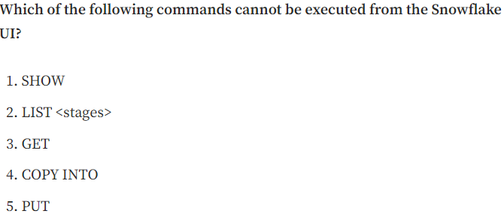

Solution: 3, 5.

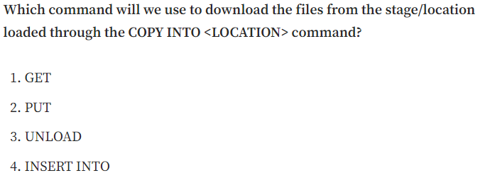

Solution. 1

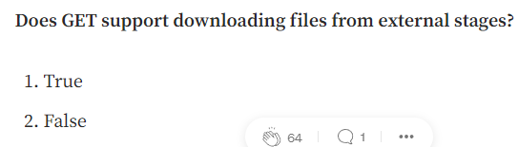

Solution: 2. If you want to download data from external stages, you need to use the cloud provider; for example, download them directly from AWS S3.

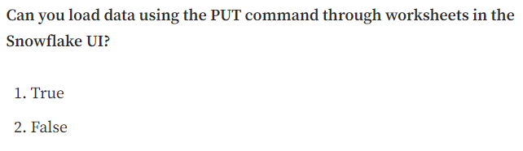

Solution: 2.

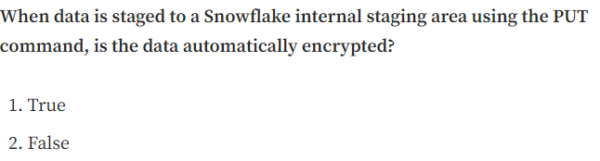

Solution: 1. Uploaded files are automatically encrypted with 128-bit or 256-bit keys.

# Tenth Chapter: Data Warehouses

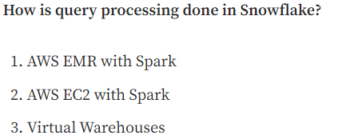

Solution: 3

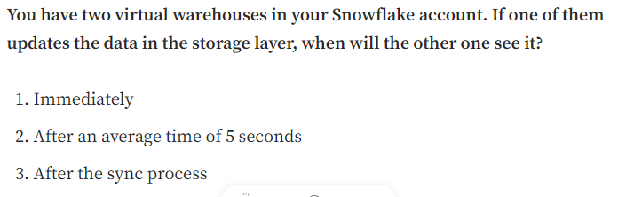

Solution: 1. All the warehouses of your account share the storage layer, so if the data is updated, all the warehouses will be able to see it.

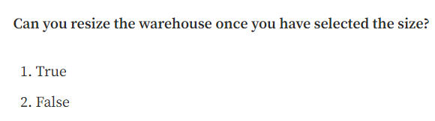

Solution: 1. You can always change the size of the warehouse depending on your needs.

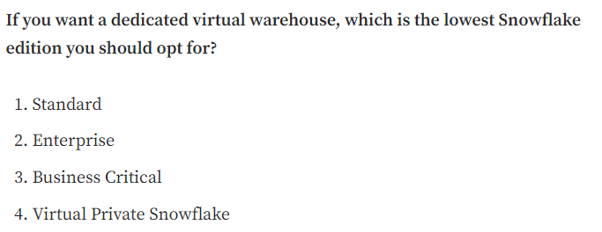

Solution: 1. In Snowflake, all the Virtual Warehouses are dedicated to the users. If you create a virtual warehouse, you will only be the one using it.

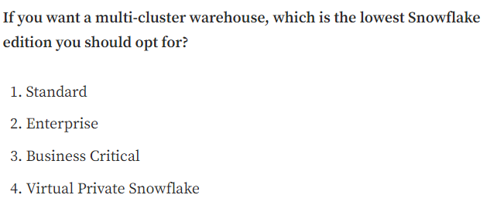

Solution: 2.

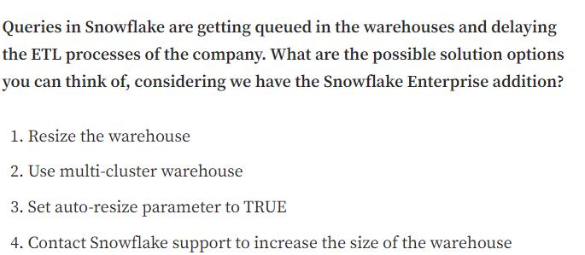

Solution: 1, 2. By resizing the warehouse, your company will scale up, reducing the time to execute big queries. Using multi-cluster warehouses, you will have more queries running simultaneously and a high concurrency when they execute.

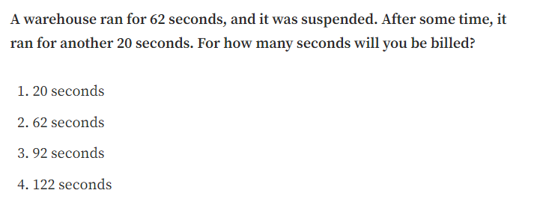

Solution: 4. 62 seconds + 60 seconds because warehouses are billed for a minimum of one minute. The price would be different if the warehouse wasn’t suspended before executing the second query.

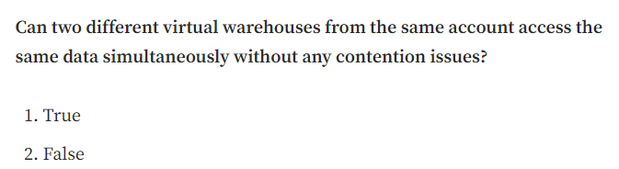

Solution: 1

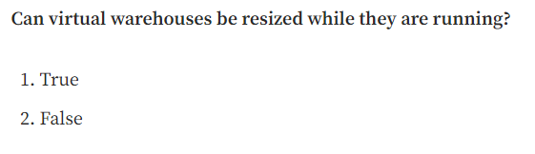

Solution: 1

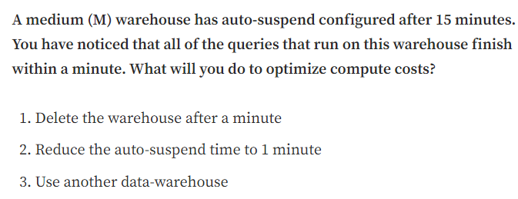

Solution: 2

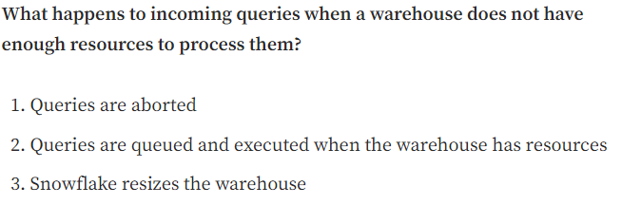

Solution: 2

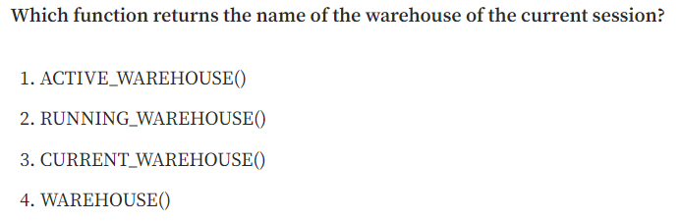

Solution: 3

# Eleventh Chapter: Resource Monitors

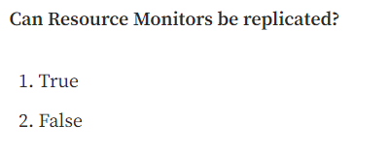

Solution: 1

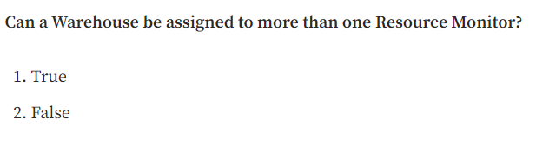

Solution: 2. You can assign a warehouse to only a single resource monitor below the account level.

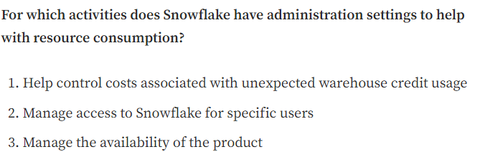

Solution: 1

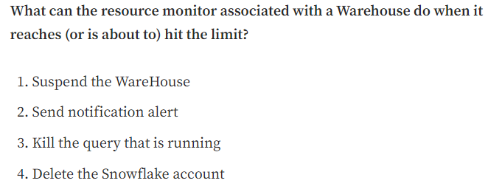

Solution: 1, 2, 3

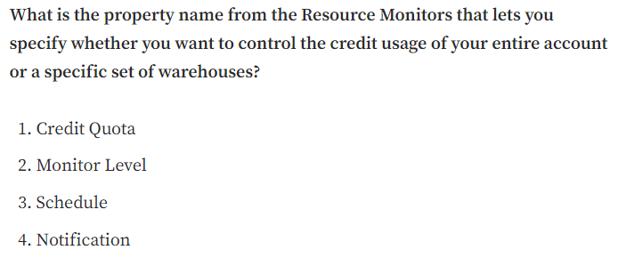

Solution: 2

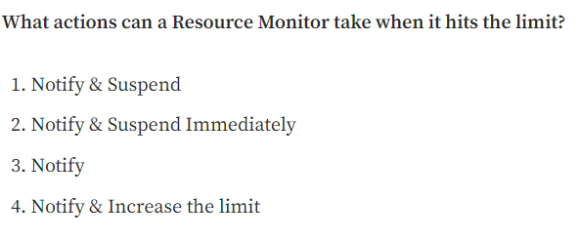

Solution: 1, 2, 3

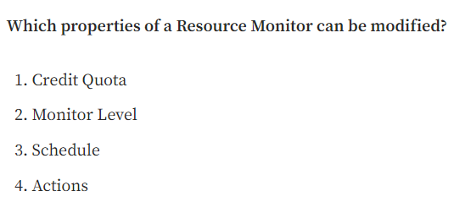

Solution: 1, 2, 3, 4

## Twelfth Chapter: Cache and Query Performance

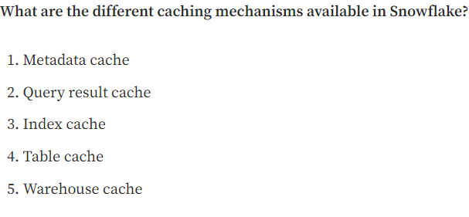

Solution: 1, 2, 5

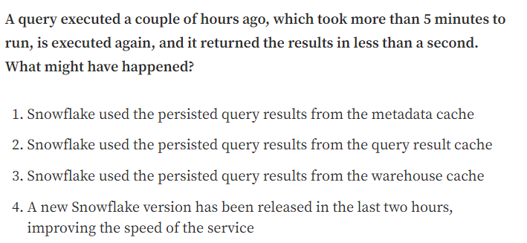

Solution: 2

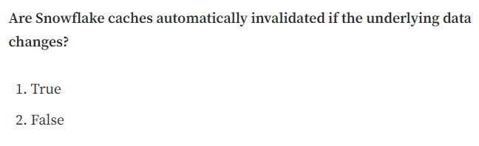

Solution: 1. If the data in the Storage Layer changes, the caches are automatically invalidated.

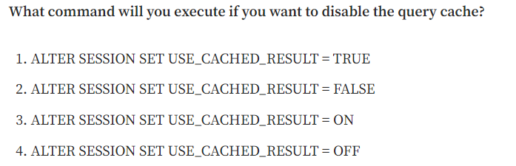

Solution: 2

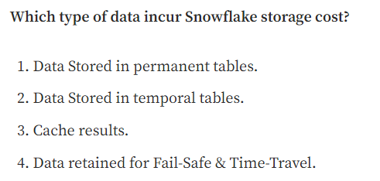

Solution: 1, 2, 4. This question is essential and has already appeared in the Snowflake pricing chapter, but we must know that cache results do NOT incur Storage costs.

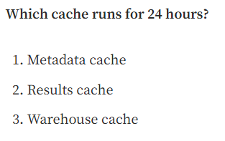

Solution: 2. Query Result cache is also known as Results Cache.

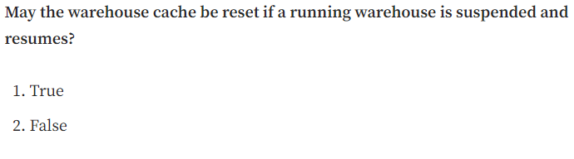

Solution: 1

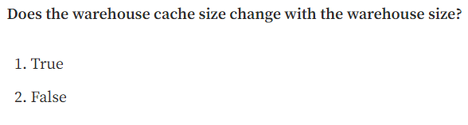

Solution: 1. The larger the warehouse is ( the more servers it has), the larger the warehouse cache size is.

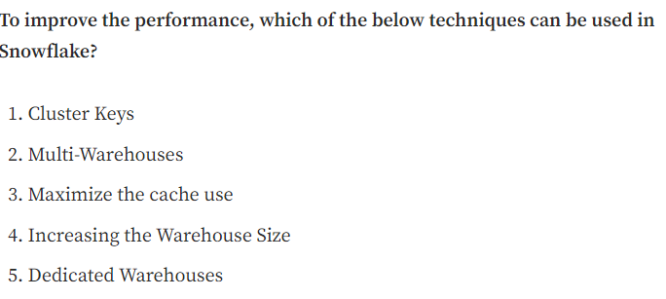

Solution: 1, 2, 3, 4, 5

# Thirteenth Chapter: Time Travel, Fail-Safe & Zero-Copy Cloning

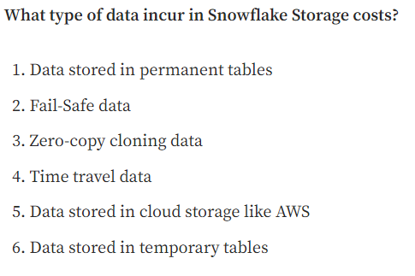

Solution: 1, 2, 4, 6. Remember that the zero-copy clone clones the metadata from the micro-partitions, not the real data. That’s why it doesn’t incur storage costs. Temporary tables also have a storage cost

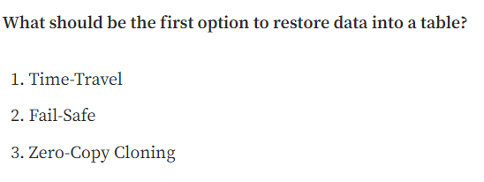

Solution: 1.

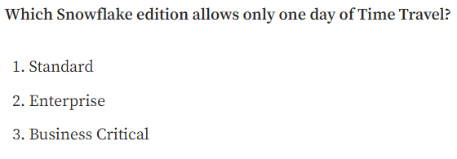

Solution: 1

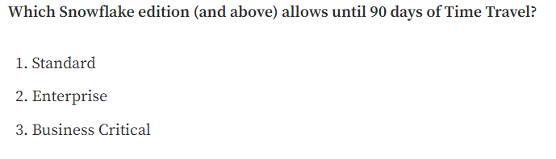

Solution: 2

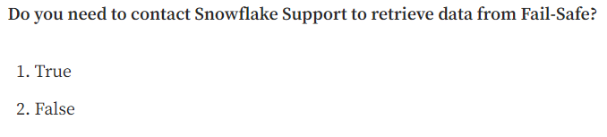

Solution: 1

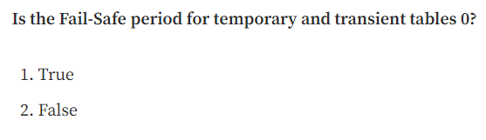

Solution: 1. Their Time Travel period is either 0 or 1 day, but they don’t have a Fail-Safe retention period.

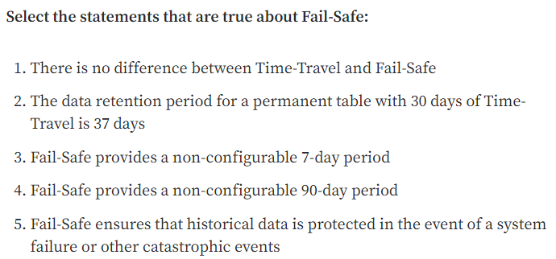

Solution: 2, 3, 5. Regarding the second option, we have 30 days of Time-Travel, apart from 7 days of Fail-Safe. 37 days in total.

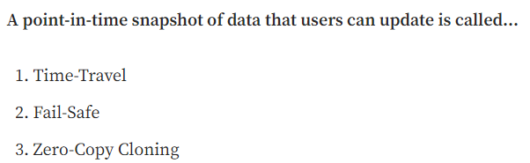

Solution: 3.

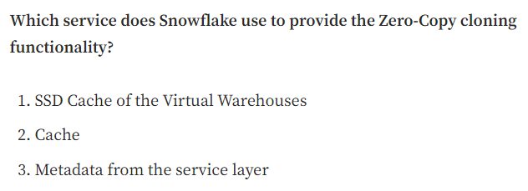

Solution: 3

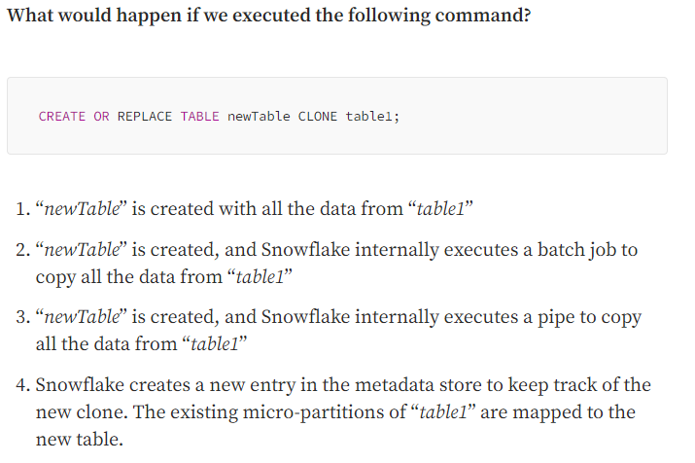

Solution: 4. This is how zero-copy cloning works.

# Fourteenth Chapter: Access Management. Roles in Snowflake

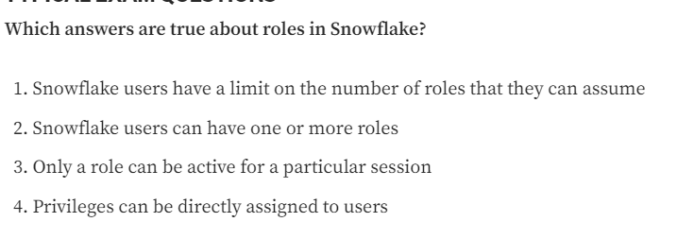

Solution: 2, 3

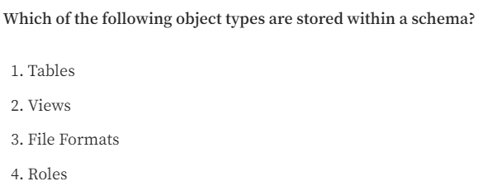

Solution: 1, 2, 3. Roles are account-level objects.

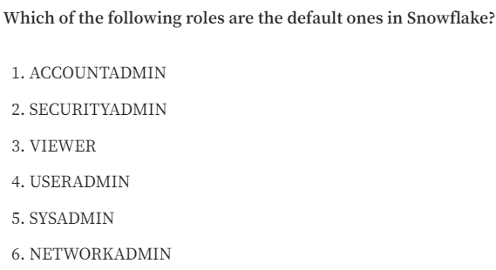

Solution: 1, 2, 4, 5

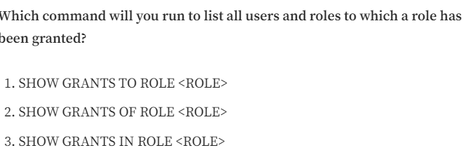

Solution: 2. “SHOW GRANTS OF ROLE” will list the users, whereas “SHOW GRANTS TO ROLE” will list the privileges that this role has access.

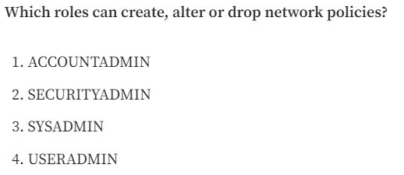

Solution: 1, 2

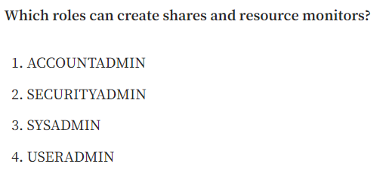---------

Solution: 1. AccountAdmins can only create Shares and Resource Monitors by default.

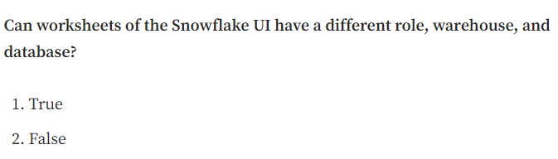

Solution: 1

# Fifteenth Chapter: Data Sharing

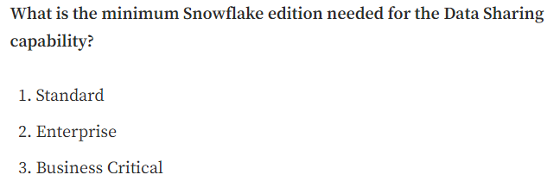

Solution: 1, 2, 3. All the data-sharing features are available for these three types of editions.

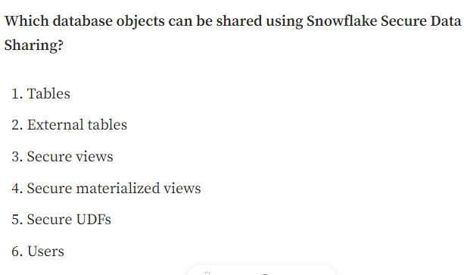

Solution: 1, 2, 3, 4, 5.

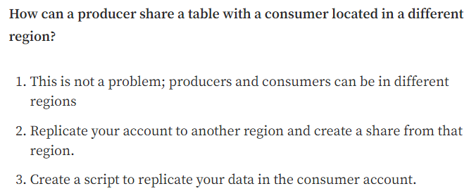

Solution: 2. Data sharing works within the same region; however, you can replicate your account to another region and then share data from that replicated account within that account’s region. This is also true across cloud platforms.

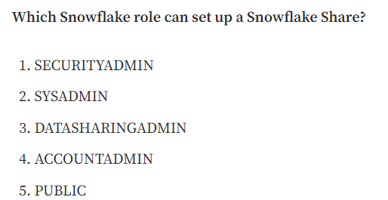

Solution: 4. Only AccountAdmins can create Shares.

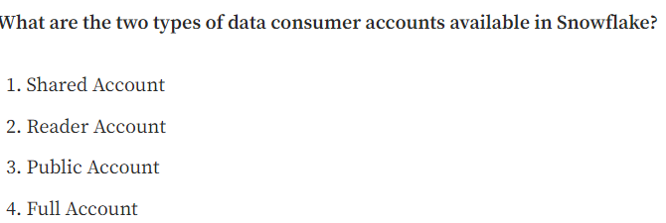

Solution: 2, 4

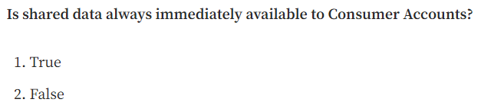

Solution: 1

# Sixteenth Chapter: Stored Procedures & User-Defined Functions for the SnowPro Core Certification

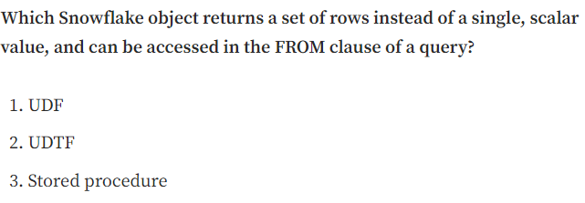

Solution: 2.

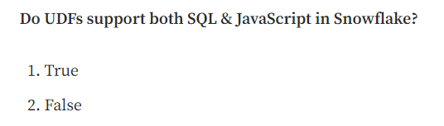

Solution: 1. They also added Python and Java recently!

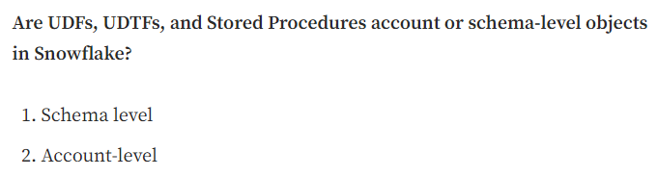

Solution: 1

## Seventeenth Chapter: Tasks & Transactions in Snowflake

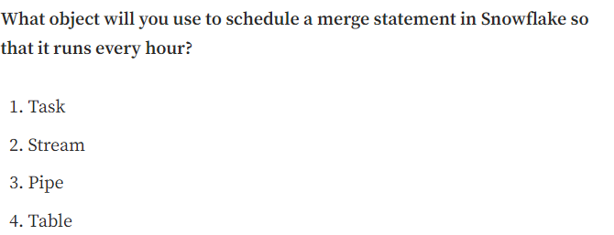

Solution: 1

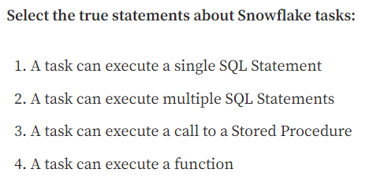

Solution: 1, 3

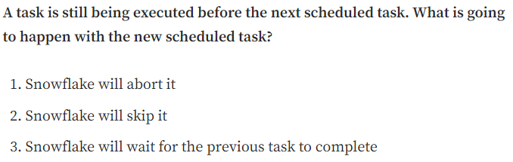

Solution: 2

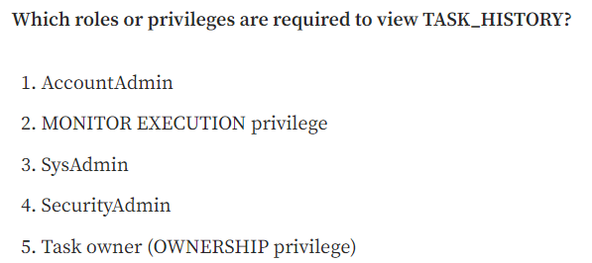

Solution: 1, 2, 5

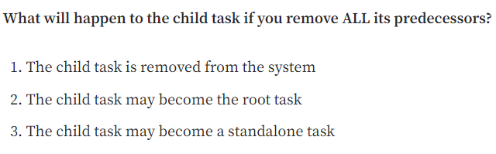

Solution: 2, 3

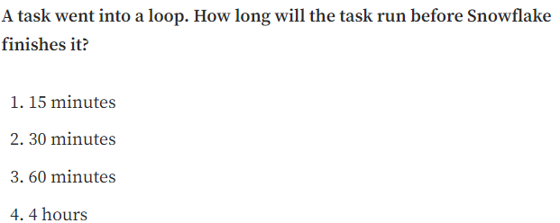

Solution: 3. Tasks have a maximum duration of 60 minutes by default. If they haven’t finished by then, they will be automatically terminated.

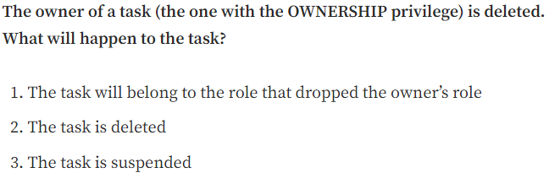

Solution: 1

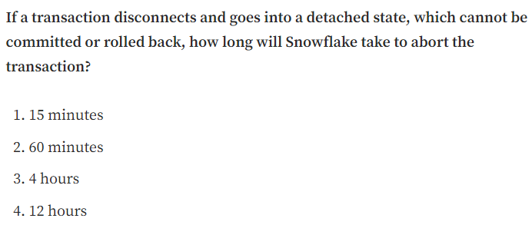

Solution: 3.

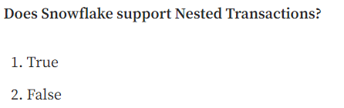

Solution: 2

## Eighteenth Chapter of the Snowflake SnowPro Core Course: Streams

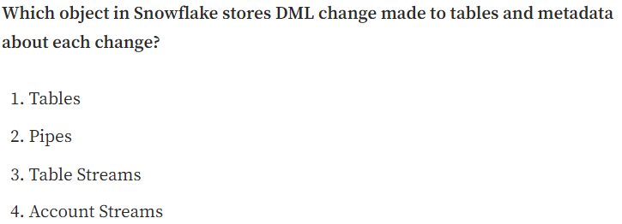------------------

Solution: 3. This is the definition of streams, also known as Table Streams.

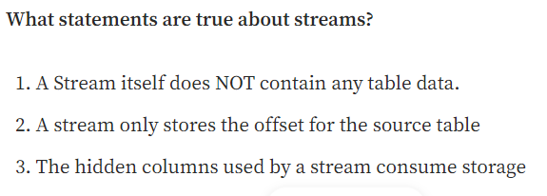

Solution: 1, 2, 3.

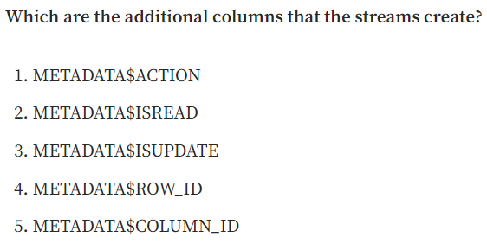

Solution: 1, 3, 4.

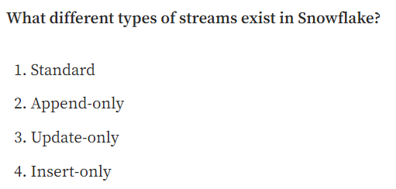

Solution: 1, 2, 4. Standard and Append-only are supported for streams on tables, directory tables, and views. External tables only support insert-only streams.

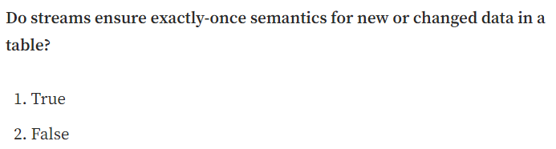

Solution: 1.

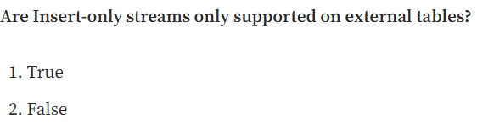

Solution: 1.

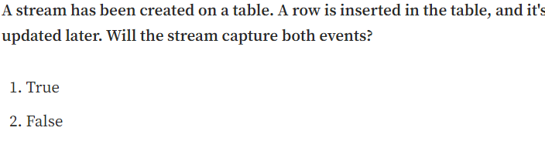

Solution: 2. This is the first example we've seen in this chapter.

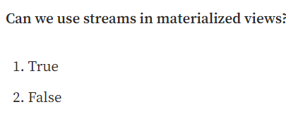

Solution: 2. As we explained in the chapter about tables and views, materialized views don't support streams at this moment. Since March 2022, views and secure views are supported, but no materialized views.

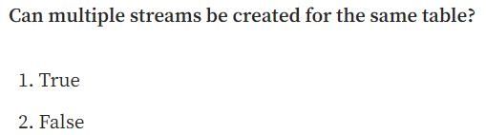

Solution: 1. Multiple streams can be created for the same table and consumed by different tasks.

# Chapter 19: Other Snowflake Objects. File Formats & Sequences

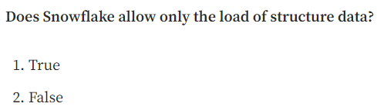

Solution: 2.

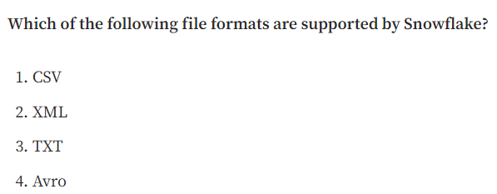

Solution: 1, 2, 4.

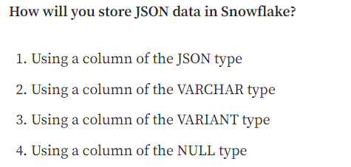

Solution: 3.

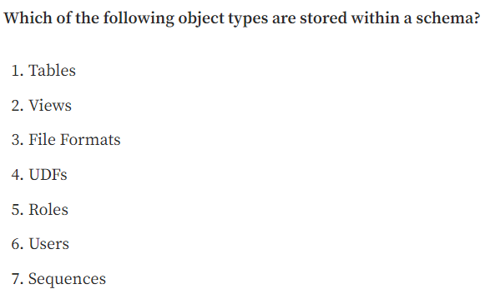

Solution: 1, 2, 3, 4, 7.

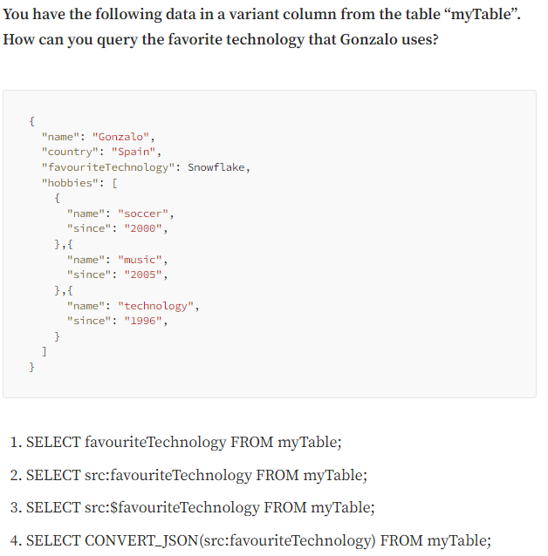

Solution: 2. In the Snowflake SnowPro Core exam, they won’t probably ask you about syntax; that’s why I didn’t explain it before. But it’s really useful to know this command.

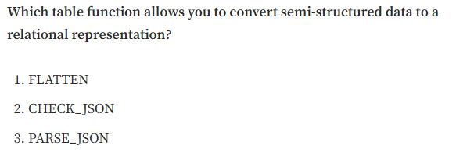

Solution: 1.

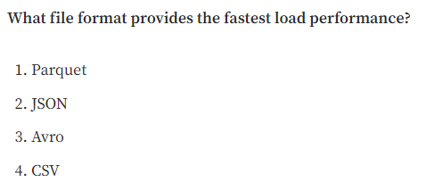

Solution: 4.

# Chapter 20: Snowflake Ecosystem, Compliance, Data Marketplace & Security

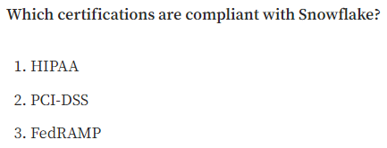

Solution: 1, 2, 3.

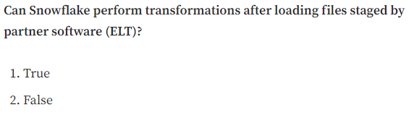

Solution: 1.

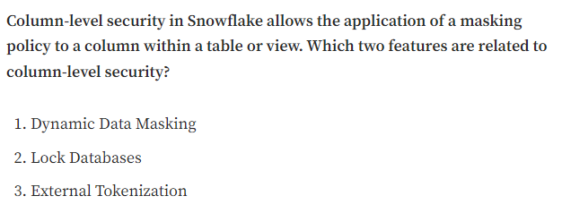

Solution: 1, 3.

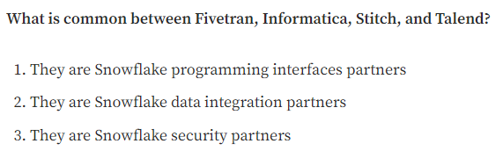

Solution: 2.